‘Supersonic Phonic Friends’ daily Phonics sessions taught discretely in EYFS and KS1 (and for those who continue to need it in KS2).

Weekly Guided Reading sessions where skills are modelled and embedded across school.

High quality stories are shared with children daily and planned for linking to our MTP or chosen to use as a teaching point for a specific skill or objective.

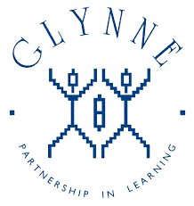

Texts chosen to broaden children’s vocabulary.

Reading a variety of books on a theme or by the same author.

Celebration of the love of books.

World Book Day, National Poetry Day, National Storytelling week.

Staff attend CPD and share ideas with colleagues.

Libraries in KS1 and KS2.

Reading workshops for parents.

Reading Assessment data in both key stages is above national.

-

Collins eBooks are available for children to read online.

-

Learning Journeys planned around quality key texts.

Shared reading where comprehension skills are modelled.

Accelerated Reader Programme across KS2. Children are quizzed on books they have read to deepen understanding.

Big Cat Phonics Reading Scheme books linking to ‘Supersonic Phonic Friends’.

Travelling Book Fairs visit school.

A wide range of genres planned for across a school year, including fiction, non-fiction, poetry, myths and legends, instructions etc.

Phonics Screening in Year 1 and Year 2.

Children take part in Local Authority Book Quizzes.

Staff are enthusiastic and passionate about reading and want to develop the same love for reading in all children.

Visits to local library and librarians coming into school.

Termly to assessments in reading to monitor progress and inform future planning.

Glynne Primary School

What does

Reading look like?